Physical Methods of Gene Delivery
Physical methods enable the direct transfer of nucleic acids into the cytoplasm, or nucleus by physical or mechanical means and without the usage of foreign substances like lipids. Various physical or mechanical methods employed in gene transfer as listed below-
1. Electroporation
2. Microinjection
3. Particle Bombardment
4. Sonoporation
5. Laser induced
6. Bead transfection
- Electroporation
• Electroporation is a mechanical method used for the introduction of polar molecules into a host cell through the cell membrane.
• This method was first demonstrated by Wong and Neumann in 1982 to study gene transfer in mouse cells.
• It is now a widely used method for the introduction of transgene either stably or transiently into bacterial, fungal, plant and animal cells.
• It involves use of a large electric pulse that temporarily disturbs the phospholipid bilayer, allowing the passage of molecules such as DNA.
The basis of electroporation is the relatively weak hydrophobic/hydrophilic interaction of the phospholipids bilayer and ability to spontaneously reassemble after disturbance. A quick voltage shock may cause the temporary disruption of areas of the membrane and allow the passage of polar molecules. The membrane reseals leaving the cell intact soon afterwards.
Procedure
The host cells and the DNA molecules to be transported into the cells are suspended in a solution. The basic process inside an electroporation apparatus is represented in a schematic diagram.
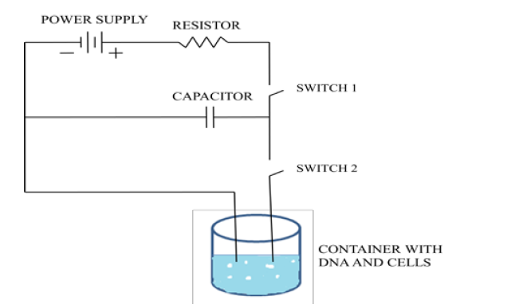
Figure: The basic setup of the electroporation apparatus

When the first switch is closed, the capacitor charges up and stores a high voltage which gets discharged on closing the second switch.
• Typically, 10,000-100,000 V/cm in a pulse lasting a few microseconds to a millisecond is essential for electroporation which varies with the cell size.
• This electric pulse disrupts the phospholipid bilayer of the membrane causing the formation of temporary aqueous pores.
• When the electric potential across the cell membrane is increased by about 0.5-1.0 V, the charged molecules e.g. DNA migrate across the membrane through the pores in a similar manner to electrophoresis.
• The initiation of electroporation generally occurs when the transmembrane voltage reaches at 0.5-1.5 V. The cell membrane discharges with the subsequent flow of the charged ions and molecules and the pores of the membrane quickly close reassembling the phospholipid bilayer.
Advantages
• It is highly versatile and effective for nearly all cell types and species.
• It is highly efficient method as majority of cells take in the target DNA molecule.
• It can be performed at a small scale and only a small amount of DNA is required as compared to other methods.
Disadvantages
• Cell damage is one of the limitations of this method caused by irregular intensity pulses resulting in too large pores which fail to close after membrane discharge.
• Another limitation is the non-specific transport which may result in an ion imbalance causing improper cell function and cell death.
- Microinjection
This physical method is mainly used for manipulation of single cells, such as oocytes, by injection of DNA, mRNA, and proteins. It can also be used for the transfer of DNA into embryonic stem cells to generate transgenic organisms.
Procedure
• The delivery of foreign DNA is done under a powerful microscope using a glass micropipette tip of 0.5 mm diameter.
• Cells to be microinjected are placed in a container. A holding pipette is placed in the field of view of the microscope that sucks and holds a target cell at the tip. The tip of micropipette is injected through the membrane of the cell to deliver the contents of the needle into the cytoplasm and then the empty needle is taken out.
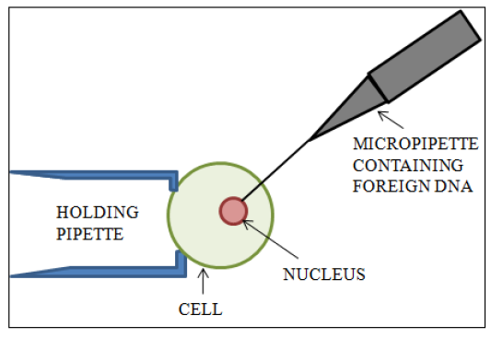
Figure: Delivery of DNA into a cell through microinjection

A major advantage of this method is the high efficiency of this method (nearly 100%). However, the method is not appropriate to transfect a large number of cells and the method requires certain operator skills. Microinjection is also very time consuming and expensive.
- Biolistic Particle Delivery
This method has been successfully employed to deliver nucleic acid to cultured cells, as well as to cells in vivo. It is mainly used for genetic vaccination and agriculture application, where cells on the surface of whole organs can be transfected. It is also termed as particle bombardment, particle gun, micro projectile bombardment and particle acceleration.
• It employs high-velocity micro projectiles to deliver substances into cells and tissues.
• This method is applicable for the plants having less regeneration capacity and those which fail to show sufficient response to Agrobacterium- mediated gene transfer in rice, corn, wheat, chickpea, sorghum and pigeon-pea.
Apparatus
The biolistic gun employs the principle of conservation of momentum and uses the passage of helium gas through the cylinder with arrange of velocities required for optimal transformation of various cell types. It consists of a bombardment chamber which is connected to an outlet for vacuum creation. The bombardment chamber consists of a plastic rupture disk below which macro carrier is loaded with micro carriers. These micro carriers consist of gold or tungsten micro pellets coated with DNA for transformation.
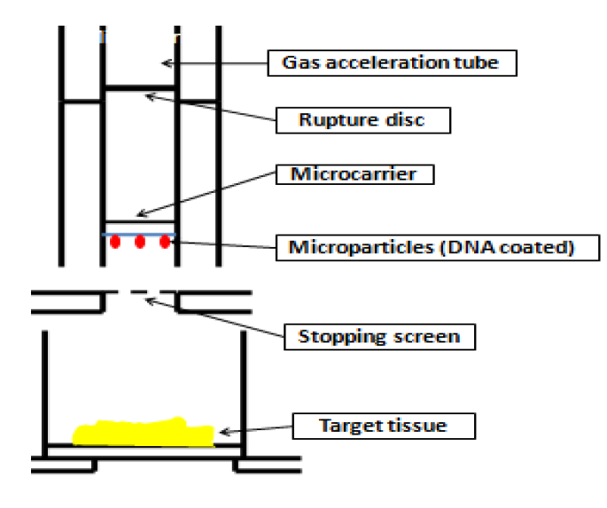
Figure: working system of particle bombardment gun
The apparatus is placed in Laminar flow while working to maintain sterile conditions. The target cells/tissue is placed in the apparatus and a stopping screen is placed between the target cells and micro carrier assembly. The passage of high-pressure helium ruptures the plastic rupture disk propelling the macro carrier and micro carriers.
The stopping screen prevents the passage of macro projectiles but allows the DNA coated micro pellets to pass through it thereby, delivering DNA into the target cells.
This technique is fast and simple and enables transfection of dividing and non-dividing cells. Also, there appears to be no limit to the size or number of genes that can be delivered. However, the mortality is very high and therefore high cell numbers is required.

